**Brayan Rosario**

**Cis-245 – Linux Administration**

**9/19/2020**

**Server Documentation**

**Ubuntu-64 bit**

***I started creating my virtual machine first, I used the typical (Recommended) required for the software.***

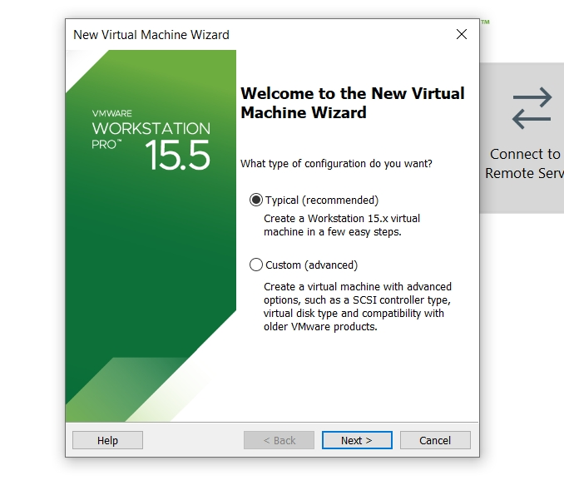

***I clicked Next, After that for the Guest Operating System Installation, it gives you two choices: Installer disc and Installer disc image file, I chose installer disc image because I downloaded the server to my UBS and I uploaded from there. And then I hit next.*** 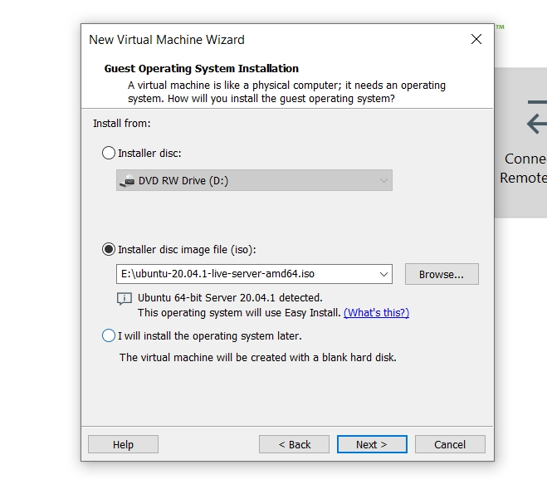

***After that, the machine will take you to the Easy Install Information which will ask you for your Full name, user name, password, and confirmation of the password. And then you hit next. take in consideration when you are going to create the (user name) that all the digits should be in lower key.***

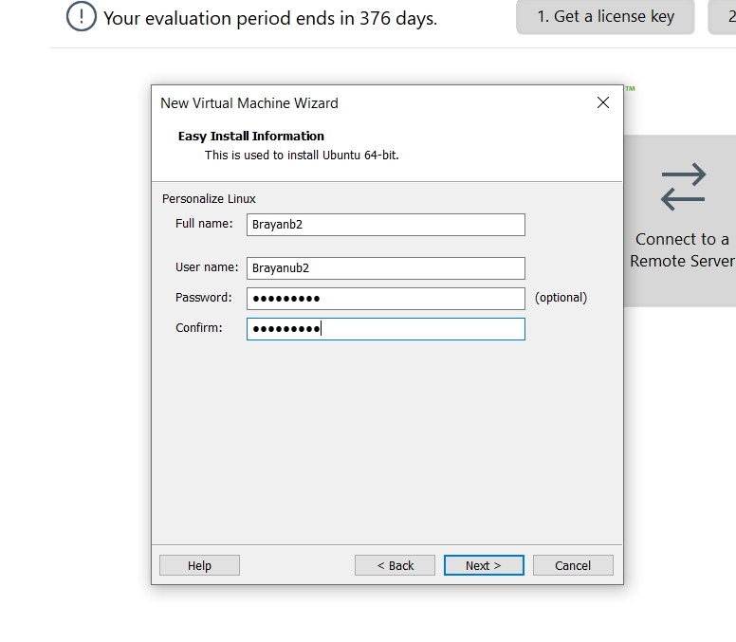

***The next step is the Name of the Virtual Machine, what name you would like to put is up to you and then the location of the server. And the hit next.***

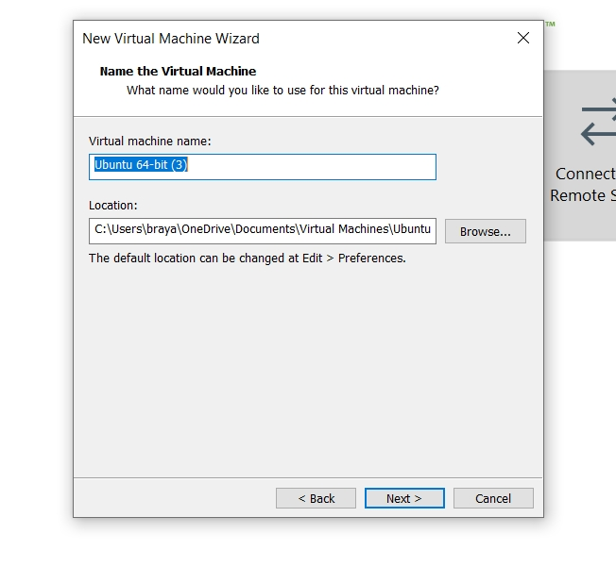

***After that, the next step coming up is the Specify Disk Capacity which will allow the virtual machine use the hard disk but it depends on how large you want the disk to be for my machine I put 20.0 GB Maximum disk size and I select the Split virtual disk into files instead of single file. And your press next.***

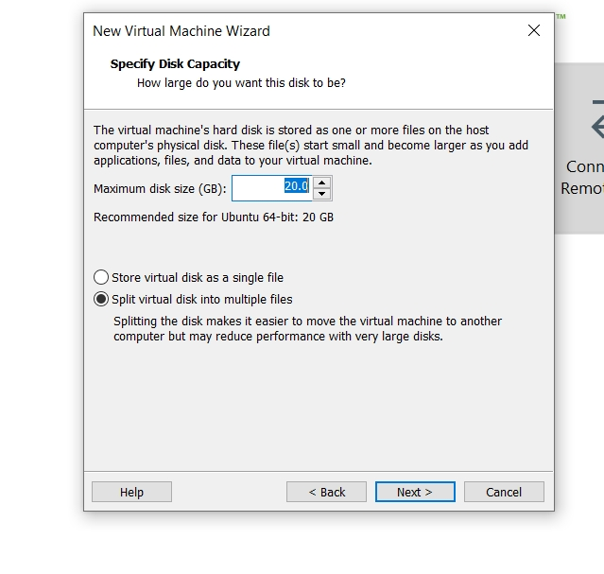

***Next, the machine will take you to the Ready to create Virtual machine which indicate all the specification that you already set in the steps you already pass, if you want to make any changes you can by selecting Customize Hardware and select if you can increase or decrease the memory RAM or the Processors. I use 4096 MB for the memory and 2 processors for my machine. Ane the hit finish after you already set all your tools.***

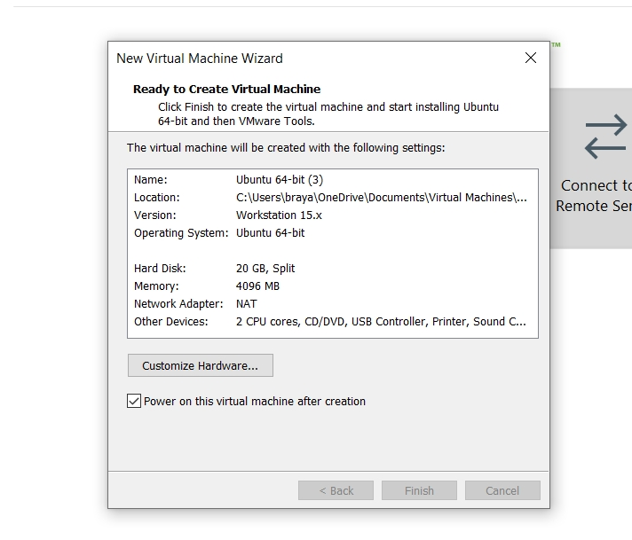

***Then the server will get into the virtual machine you have to wait a couple seconds for the machine to pop up.***

***Then you will get into the Ubuntu server, the first thing the Ubuntu server will requires is to select the language of your preference.***

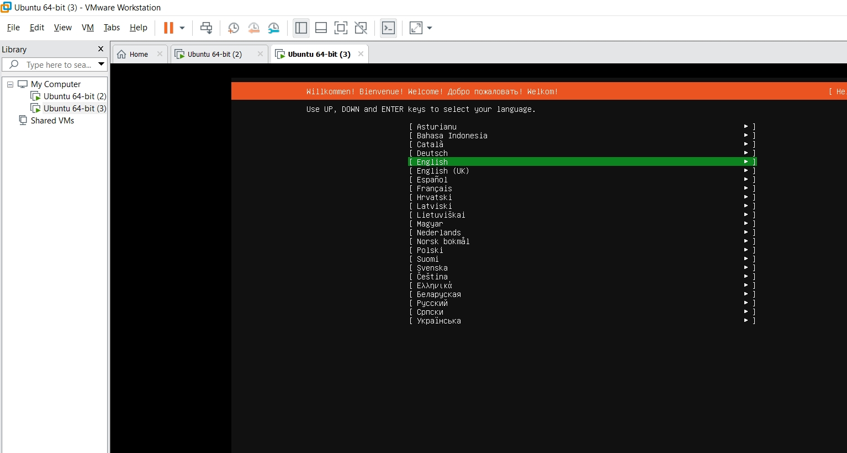

***After that, the server will take you to the Keyboard configuration in which you need to select in what language you want your keyboard to be. I select mine in English. and then you hit done to move to the next step.***

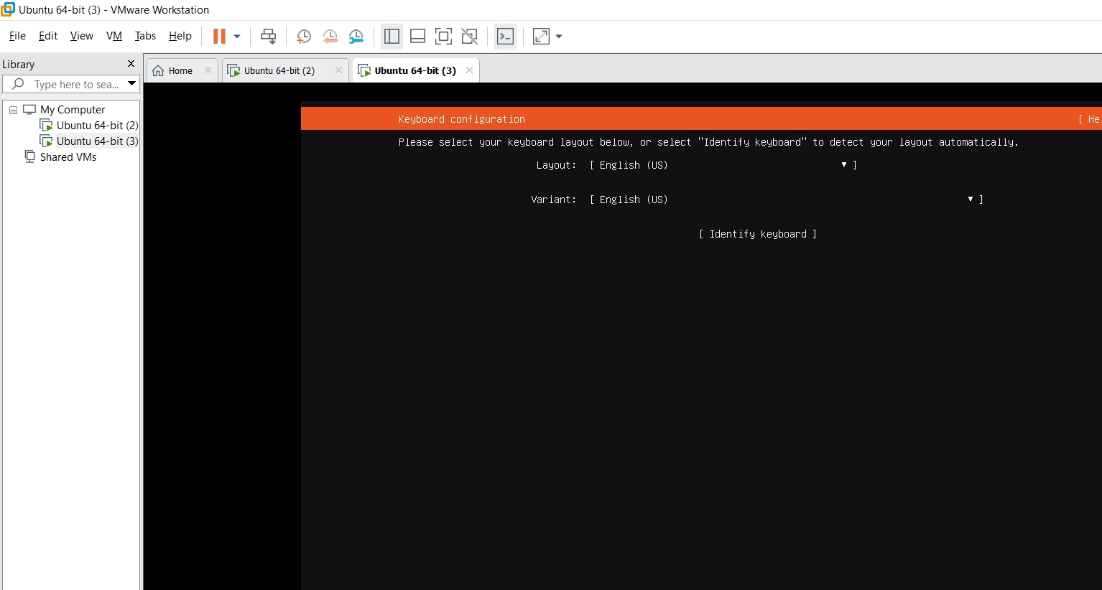

***Then, the next step is the network connection which allow at least one interface to talk to another machine. And which preferably provides sufficient access for updates. then you hit Done.***

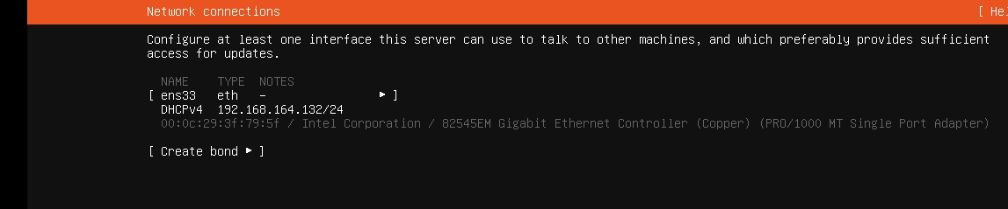

**After that, the server will take you to the configuration proxy which you can use if the server provides you the URL but if no you can just press done and move over.**

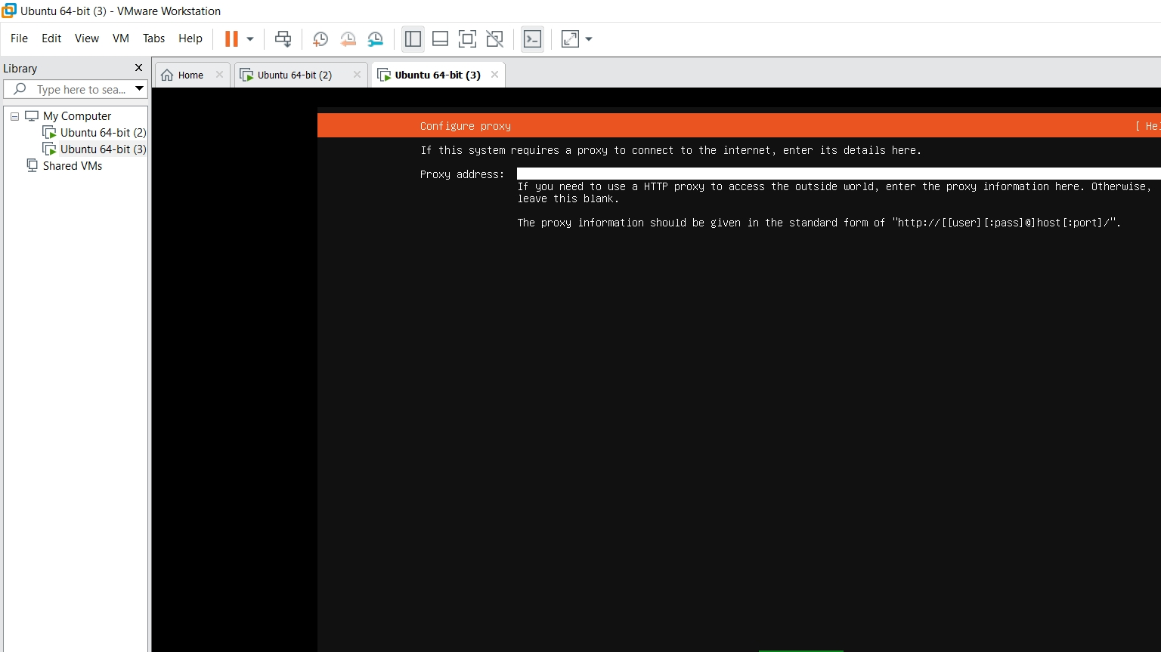

**Then, you have the Configure Ubuntu archive mirror which use and alternative mirror and it already has the ubuntu URL posted in the white line you just need to press Done and move to the next step.**

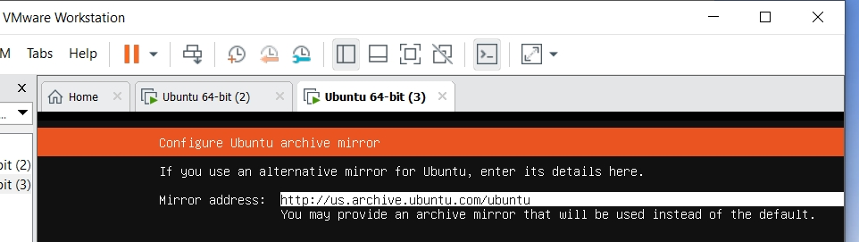

**Then the following step is the GUIDE STORAGE CONFIGURATION in which it will ask you if you want to use the entire disk. As it is already selected you just press Done and move on.**

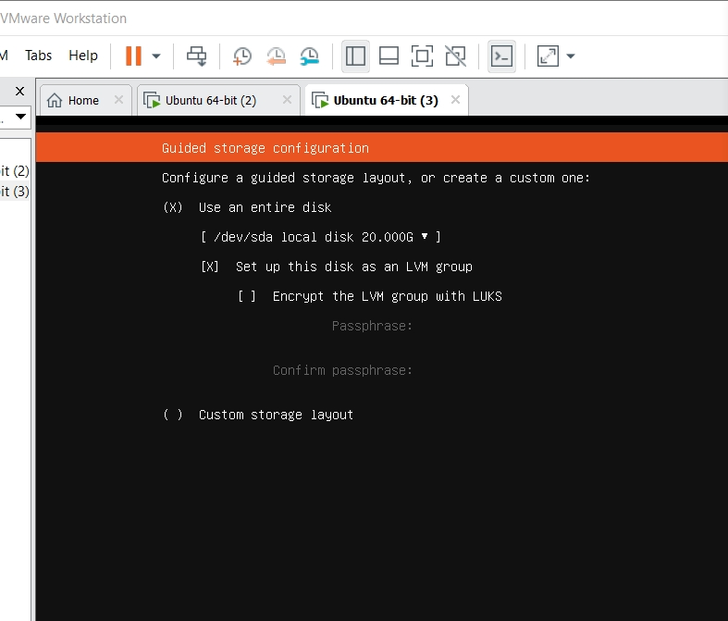

**Then, the next step is Storage Configuration in this step will display the File system summary, the Available Devices, And the Used Devices with all the specifications and details. In this step I just press done and continue.**

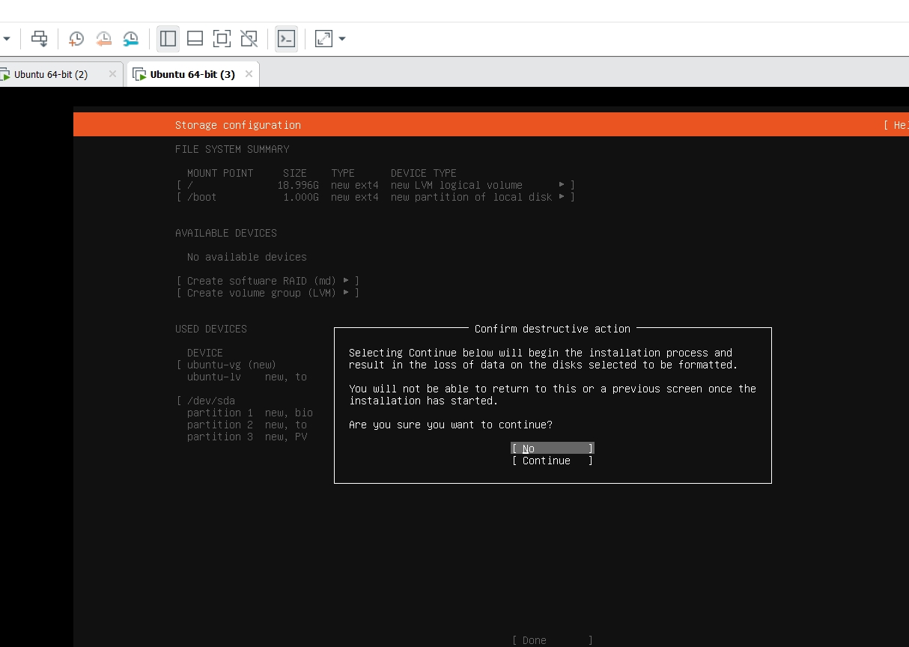

**AND then it will take you to the PROFILE SETUP in which you can select your full name, your server’s name, pick name, and password. After you do all that you can move to another step**

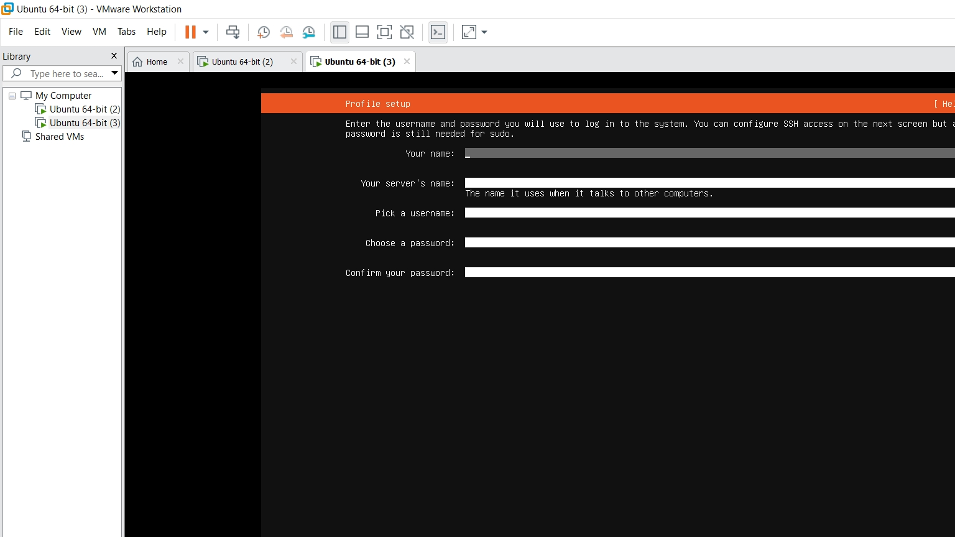

**The next step is for SSH SETUP, is up to you if you want to install the Openshh server package or not I just press done and move forward.**

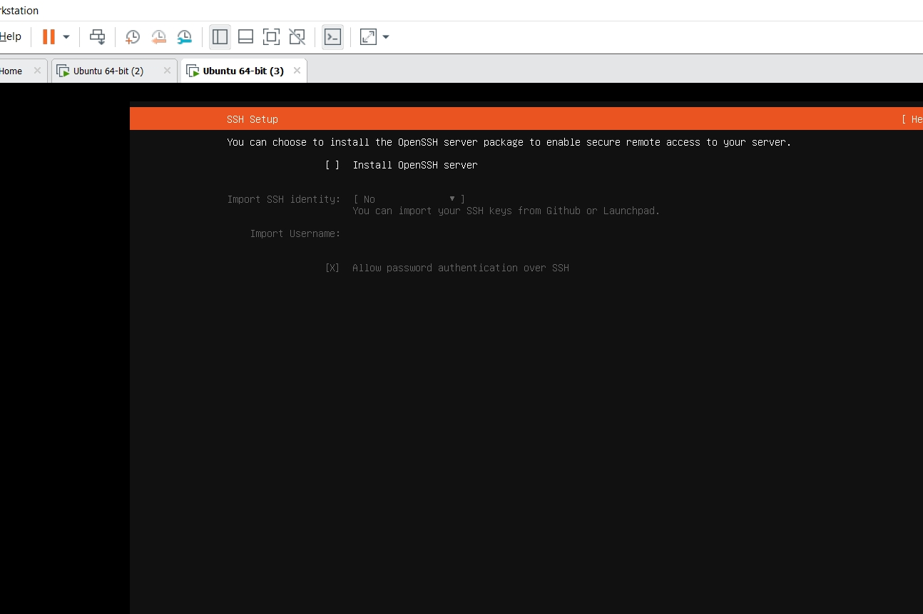

**The next, is the Featured Server Snaps which will display a lot of server and give you the option of select any of your preference is available and is up to you if you want to select one of the options. And the press Done.**

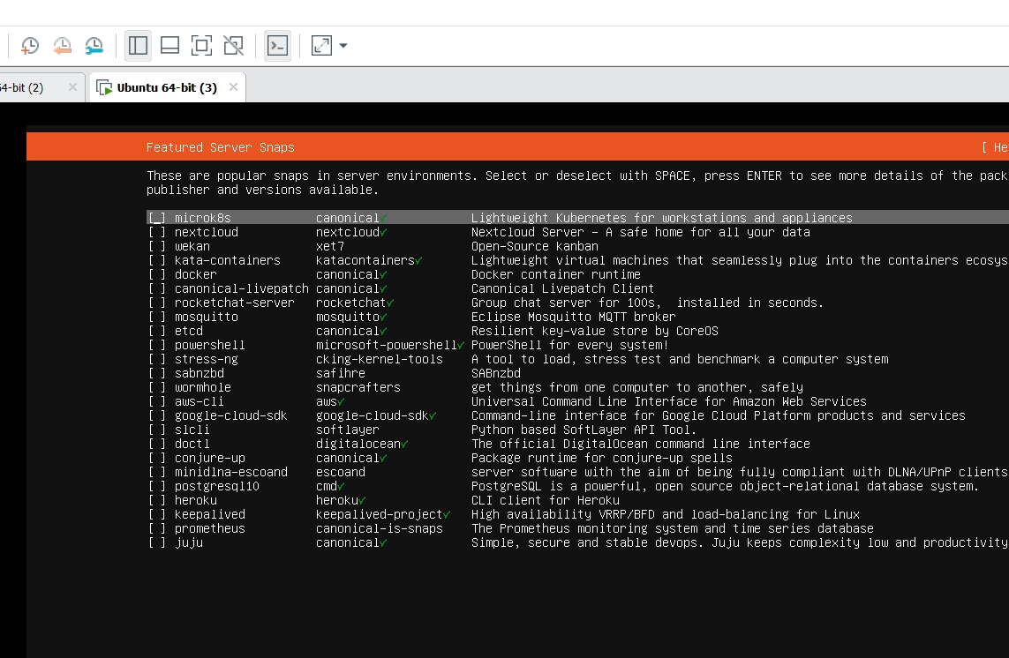

**After that when you press done the installation will started and all the set up that you select will be install as well. And then your press (Done). and wait until the machine pop up. And then you rebooted.**

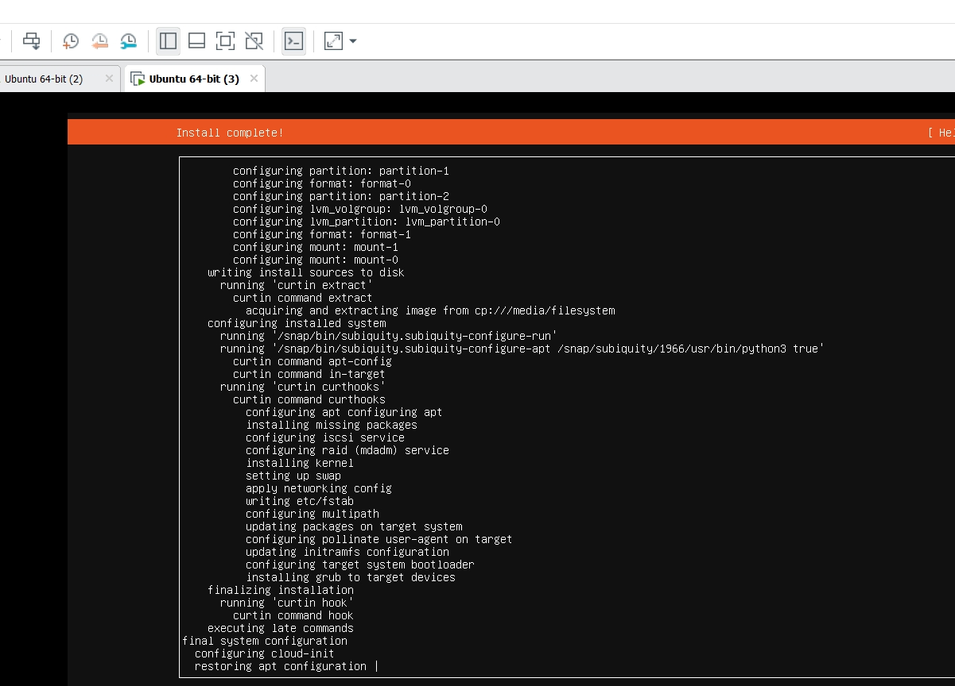

**This is all your need to see in order to confirm that all the sets up is getting installed.**

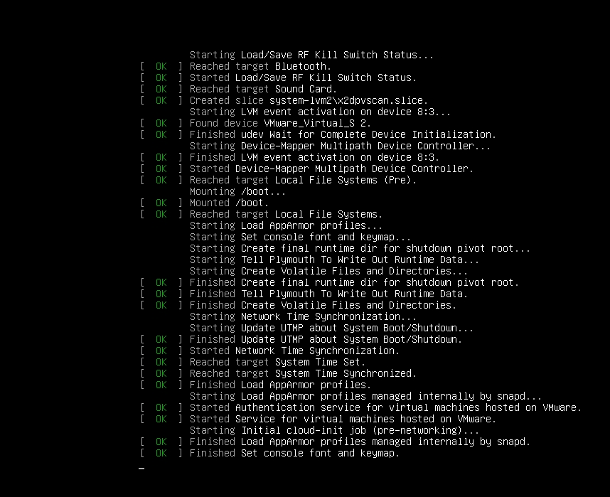

**And then after that the server will ask you to put your login credentials. and that’s all you need to do in order to install the ubuntu server on a virtual machine.**

